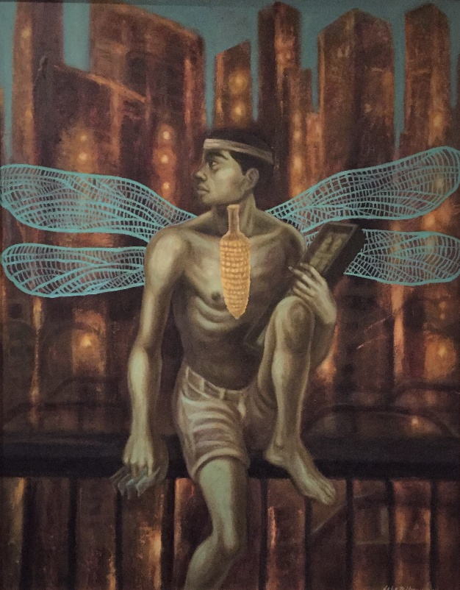

*Jeho Bitancor*

“Tutubi”, 2010.

Oil on canvas mounted on board.

28½” X 36”

“Tutubi” is Tagalog for “Dragonfly”